Operational Concept Description (OCD)

Project RAP (Rapid Access Pass)

Team 1

Team members and roles
Lizz - Project Manager

Nakul - Software Architect

Ian - Requirements Engineer

Jorge - Feasibility Analyst

Rishi - Operational Concept Engineer

Katherine - Life Cycle Planner

Andrew Borba - Prototyper

09/12/2013

Version History
Date | Author | Version | Changes made | Rationale
08/20/12 | SK | 1.0 | - Original for CSCI477; Tailored from ICSM OCD Template | - To fit CS477 course content
9/12/2013 | Team RAP | 1.1 | - Filled out initial OCD for project | - Document the Project RAP Initiative

Table of Contents
Operational Concept Description (OCD) i
Version History ii
Table of Contents iii
Table of Tables iv
Table of Figures v
1. Shared Vision 1
1.1 Overview of the system 1
1.2 System Boundary and Environment 2
2. System Transformation 4
2.1 System Objectives, Constraints and Priorities 4
2.2 Proposed New Operational Concept 6

Shared Vision

Overview of the system

<< In order to understand or know what projects or related initiatives are required for program management we create a Program Model as shown below. The model helps in designing and managing programs. Understanding the concept of a program – how it is different from traditional projects and what it brings to them – is the first major step to embarking on the route to effective, proactive benefits management. The Program Model starts out with five components as shown in the table below >>
Table 1: The Program Model
Stakeholders  (Who is accountable for the initiatives) | Initiatives  (What to do to realize benefits) | Value Propositions  (Benefits i.e Why) | Beneficiaries  (Who derives value)
- Development Team (Team RAP)  - We need to partner with the LA Metro for access to their protocols. | - Develop a mobile application integrated with existing infrastructure to purchase and use LA Metro tickets. | - Convenience for customers to purchase and use metro tickets  - Ticket elimination reducing cost and environmental impact  - Technological advancement of public transportation | - Customers of the LA Metro  - LA CMTA Employees

<< The following table is an example of the above program model from a Volunteer Management project for California Science Center >>

Table 2: The Program Model of California Science Center Volunteer Management Project - example
Key Partners | Key Activities | Value Proposition |  | Customer Relationships | Customer Segments
- LA Metro | - Software Design and Development  - Integration with Metro infrastructure  - Marketing of application | - Convenience for customers to use LA Metro.  - Save LA Metro from manufacturing cost of TAP cards  - Technological advancement of public transportation. |  | - LA Metro  - Apple Appstore  - Android Store  - Windows Phone Marketplace | - Transportation companies.
- LA Metro | Key Resources  - PhoneGap API  - Development Team  - NFC Technology  - QR Technology |  |  | Channels  - Application Stores  - LA Metro Website  - Posters and Billboards at stations.
Cost Structure  - Development Team  - Back-End System Administrator |  |  | Revenue Streams  - Flat Fee for project implementation  - Recurring fee per ticket sale through application

System Boundary and Environment

System Transformation

System Objectives, Constraints and Priorities

Capability Goals
<< Provide a brief enumeration of the most important operational capability goals. A “capability” is simply a function or set of functions that the system performs or enables users to perform. To facilitate traceability between capability goals listed in the OCD and references to them from other artifacts (Requirements, Architecture, LifeCycle plan, and Feasibility Evidence ), assign each capability a unique designation (e.g. OC-1) and a short descriptive name.
Capability Goals | Priority Level
OC-1 Cross-platform Compatible: The application is compatible with both iOS and Android. | Must have
OC-2 Account Creation: The application is able to create new accounts, update information, and log in users using existing information. | Must have

Level of Service Goals
<< Identify in a table the desired and acceptable goals for the proposed new system's important levels of service. >>
Table 3: Level of Service Goals
Level of Service Goals | Priority Level

Organizational Goals
<< List briefly the broad, high-level objectives and aspirations of the sponsoring organization(s) and any organizations that will be using and maintaining the new system. The goals should be expressed in terms of (or referenced to) the Value Propositions, and should only include the goals that indicate what the organization wishes to achieve by having the proposed system (e.g., increase sales, profits, and customer satisfaction). Each goal in this section should relate to one or more of the Value Propositions.
Provide a brief enumerated list of goals. To facilitate traceability, assign each goal a unique number (e.g. OG-1).
OG-1: Increase convenience for ticket buyers.
OG-2: Increase efficiency of ticket processing.
OG-3: Decrease barriers to public transit system by advancing technologically.

Constraints
<< Identify constraints of the project. Constraints will be derived from your WinWin negotiation and/or client’s meeting. Constraint is a limitation condition that you have to satisfy for your development project. Examples of Constraints are:

CO-1: Align with Current Infrastructure: The new application must work with the turnstiles and scanners currently installed (this is with the assumption that Metro will not allow us to modify current infrastructure).
CO-2: Zero Monetary Budget: The selected COTS should be free or no monetary cost.
CO-3: Java as a Development Language: Java will be used as a development language. >>

Proposed New Operational Concept
<< This section contains information about the transformation of new operational concept that will be introduced to the system. >>

Element Relationship Diagram
<< The element relationship diagram summarizes the major relationships among the primary elements and external entities involved in the proposed new system. The entities include actors or users as well as external systems and components that interface with the system. The dashed box represents your proposed system, the boxes outside the dashed box represent external element that your system has to communicate with.
Note that the example is more in the style of a data flow diagram than in the style of Chen's ER diagram or of an EER diagram; any of these notations is fine, as the content is far more important than the style. The followings are an example and a template for Element Relationship diagram. >>
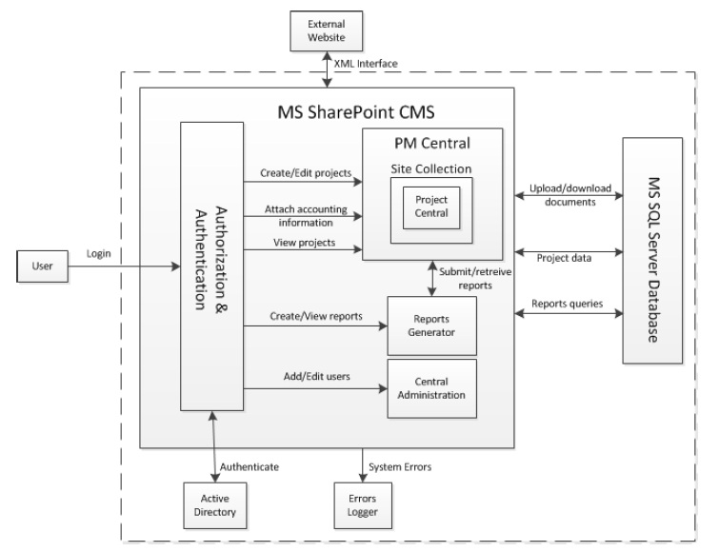
Figure 1: Element Relationship Diagram of Transportation Grant Fund system
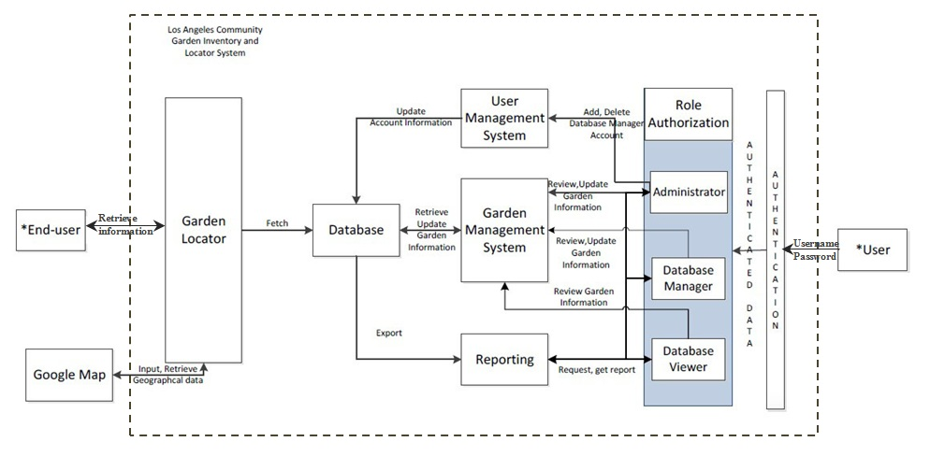
Figure 2: Element Relationship Diagram of
the Los Angeles Community Garden Inventory and Locator
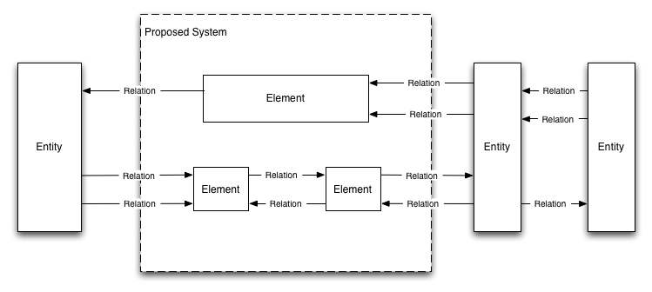
Figure 3: Element Relationship Diagram

Business Workflows
<< Characterize the new operational concept in terms of the flow of works through the proposed new system. The workflows will be illustrated in the form of business activity diagram(s). It will show the overview of the business activities flowing in proposed new system. As appropriate, indicate future capabilities of the new system or major differences from the current system as well. >>
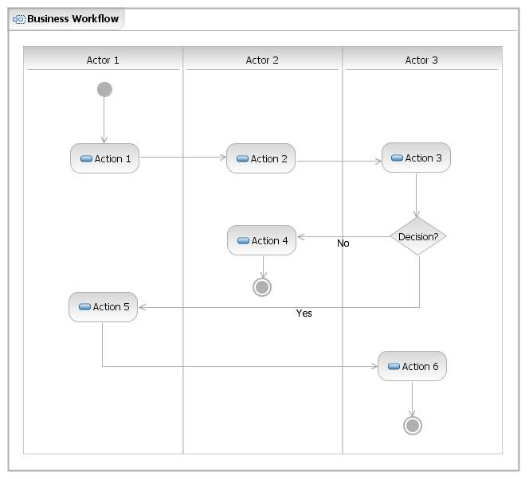
Figure 4: Business Workflows Diagram
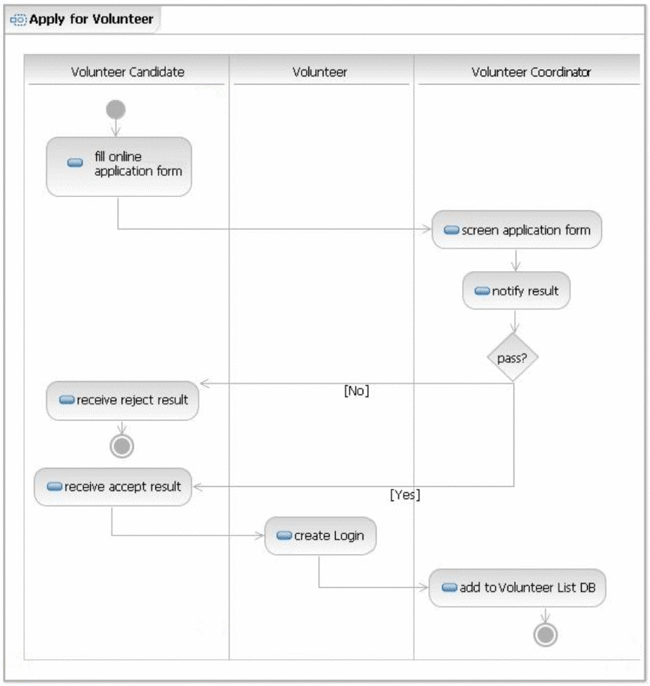
Figure 5: Business Workflow Diagram of Volunteer Tracking System - Example

